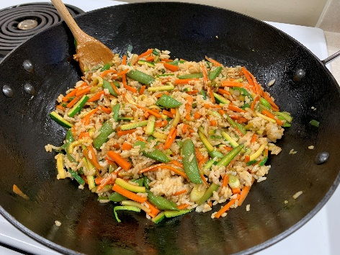
VEGETABLE STIR-FRY
Yield - Serves 4

Ingredients:
- 2 cups cooked rice (can be white rice or brown rice – prepare as directed on package.)
- 1 1/2 carrots – washed, trimmed, peeled, and cut julienne style
- 1/2 zucchini – washed, trimmed, and cut julienne style
- 2 scallions, trim and bias cut to ¼
- 1/4 pkg. frozen snow peas, or snap peas
- 2 Tbsp. cooking oil
- 4 Tbsp. water
- 4 Tbsp. cooking sherry
- 4 Tbsp. soy sauce
- 2 1/2 tsp. cornstarch
- Pinch of pepper

Directions:

- Prepare Rice
- Prepare ALL fresh produce.
- Make the sauce by combining water, sherry, soy sauce, cornstarch and pepper in a small bowl and mix well.
- Heat oil in wok for 30 seconds at high hear or 400° if using electric Wok.
- Add carrots to hot oil and stir-fry, stirring constantly, for 1 minute.
- Add zucchini, stir-fry, stirring constantly, for 1 minute.
- Add snow/snap peas and scallions and stir-fry, stirring constantly, for 1 minute.
- Move veggies to outer (cooler) rim of wok and pour sauce into center.
- When it bubbles and thickens, turn off and stir veggies back in.
- Stir cooked rice in, or serve on the side.
- Serve Immediately.

